HIKVISION backend documentation
({{backend url}}: 172.17.30.228:3000)
- Register user
url: (Method + URL)
POST {{backend url}}/students/register
params:
name (text) required
employeeNo (text) required | must be unique
faceImage (file) constraints: (filesize less => than 200KB, file type => JPEG or JPG) required
format:
multipart/form-data
example:
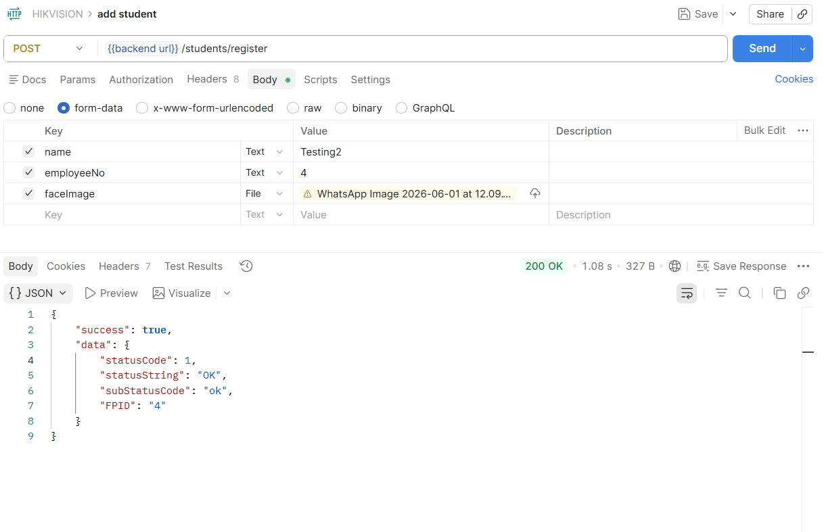
- Get all users (30 per request)
url:
GET {{backend url}}/students? searchID=abc123&position=30&limit=30
params:
limit “query param” optional
position “query param” optional
description of params:
without params gives response for only first 30 users
limit sets the users returned per request (cannot be greater than 30 per request due to device limitation)
position skips the number of users from the response (setting position to 30 skips the first 30 users and gives the users 31 onwards) allowing data to be requested in batches
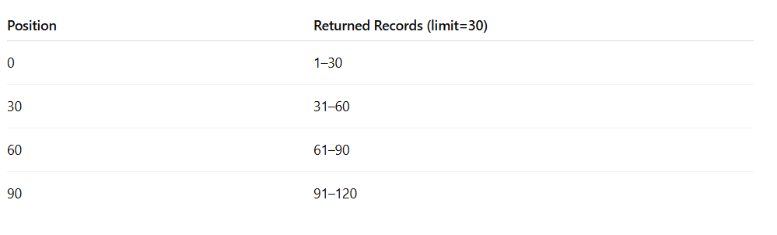
format:
JSON
example:
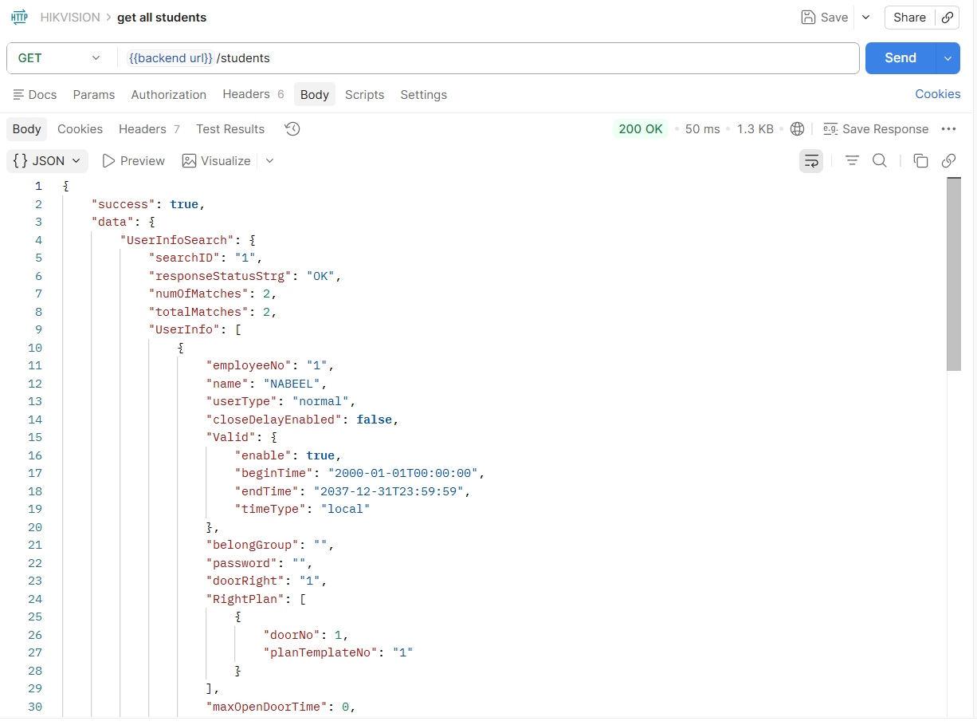

- Delete user
url:
DELETE {{backend url}}/students/{{studentId}}
params:
studentId “url parameter” required
format:
JSON
example:
